PRACTICAL FILE

NAME:TANISH SINHA

ROLL NO:22/28032

**1.Plotting and fitting of Binomial distribution and graphical representation of probabilities.**

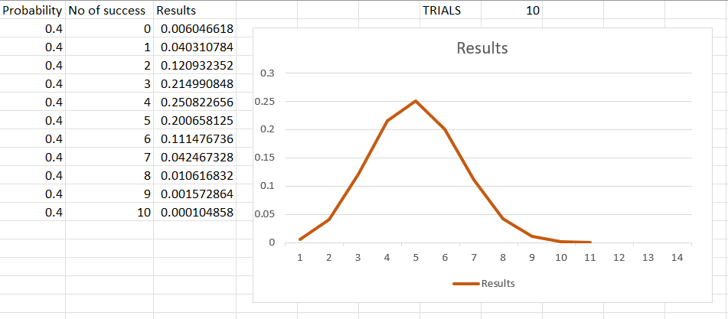

FORMULA USED=BINOM.DIST(B2,$H$1,A2,FALSE)

B2 is no of success,H1 is trials and A2 is probability

**3. Plotting and fitting of Poisson distribution and graphical representation of probabilities.**

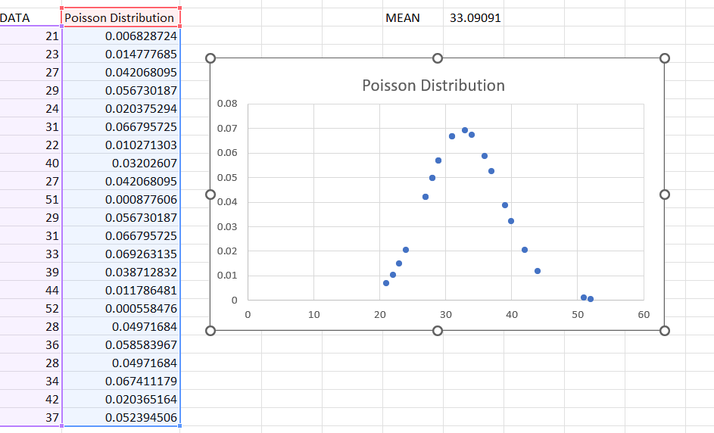

FORMULA USED =POISSON.DIST(A22,$G$21,FALSE), =AVERAGE(A22:A43)

**7. Plotting and fitting of Normal distribution and graphical representation of probabilities.**

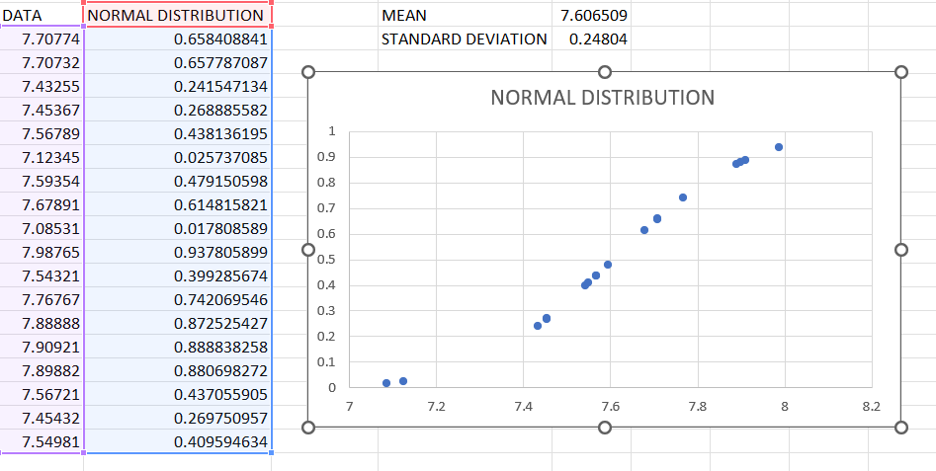

FORMULA USED =AVERAGE(A49:A66), STDEV(A49:A66),NORM.DIST(A49,$E$48,$E$49,TRUE)

**8. Calculation of cumulative distribution functions for Exponential and Normal distribution.**

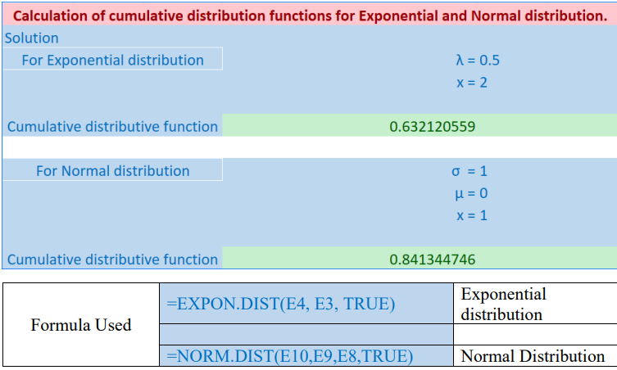

E4, E3 contain the x and λ respectively. E8, E9, E10 contain σ, μ and x respectively

**9. Application problems based on the Binomial distribution.**

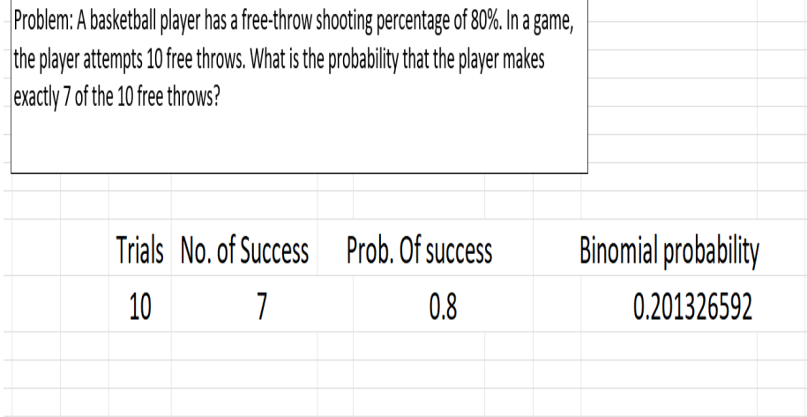

**10. Application problems based on the Poisson distribution.**

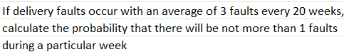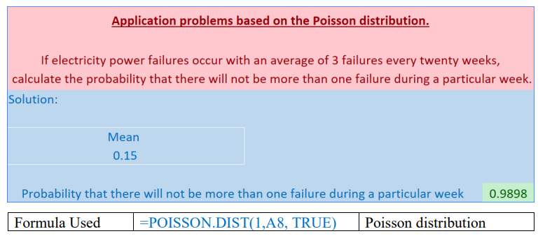

A8 contains mean of the data

**11. Application problems based on the Normal distribution.**

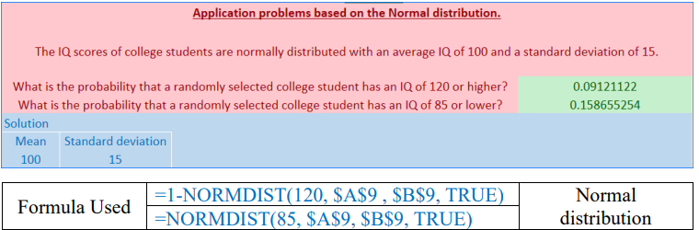

A9 and B9 contain means and standard deviation of the data respectively.

**12. Presentation of bivariate data through scatter-plot diagrams and calculations of covariance**

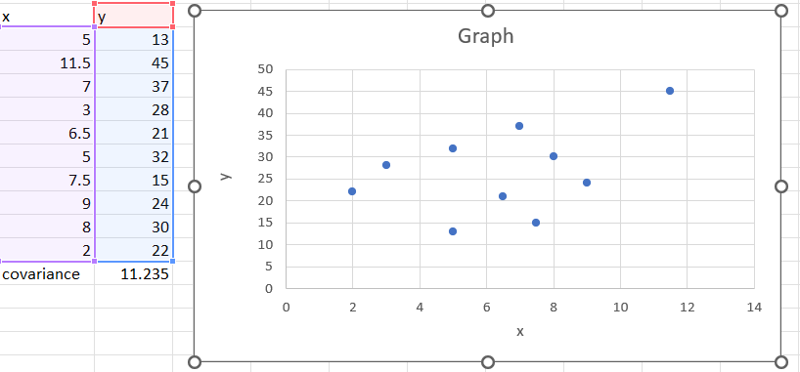

Formula=COVAR(A6:A15,B6:B15)

Here A6:A15 contain the data of x and B6:B15 contain the date of y

**13. Calculation of Karl Pearson’s correlation coefficients.**

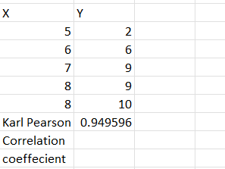

Formula=PEARSON(A26:A30,B26:B30)

A26:A30 contain data of X,B26:B30 contain data of Y

**14. To find the correlation coefficient for a bivariate frequency distribution.**

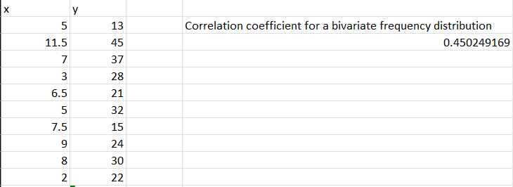

Formula=CORREL(A6:A15,B6:B15)

A6:A15 contain data of x,B6:B15 contain data of y

**15. Generating Random numbers from discrete (Bernoulli, Binomial, Poisson) distributions.**

**16. Generating Random numbers from continuous (Normal, Uniform) distributions.**

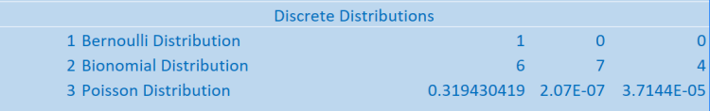

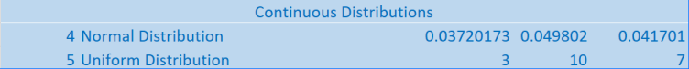

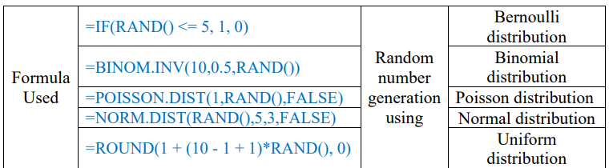

**2.Plotting and fitting of Multinomial distribution and graphical representation of probabilities.**  
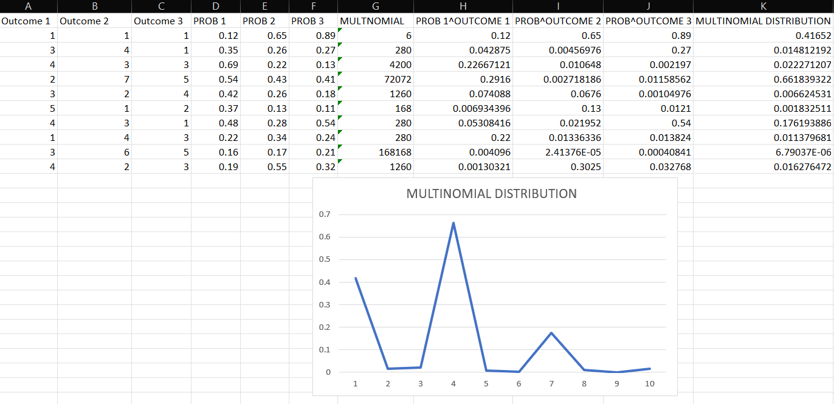

Formula =MULTINOMIAL(A2:C2)

PROB1^OUTCOME 1=D2^A2

PROB2^OUTCOME 2=E2^B2

PROB3^OUTCOME 3=F2^C2

MULTINOMIAL DIST=G2*PRODUCT(H2:J2)

**4.Plotting and fitting of Geometrical Distribution and graphical representation of probabilities**

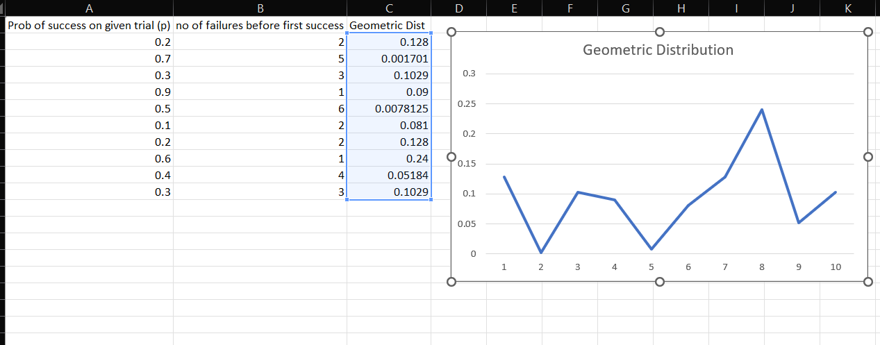

Formula=(1-A2)^B2*A2

which gives geometrical distribution

**5.Plotting and fitting of Uniform Distribution and graphical representation of probabilities**

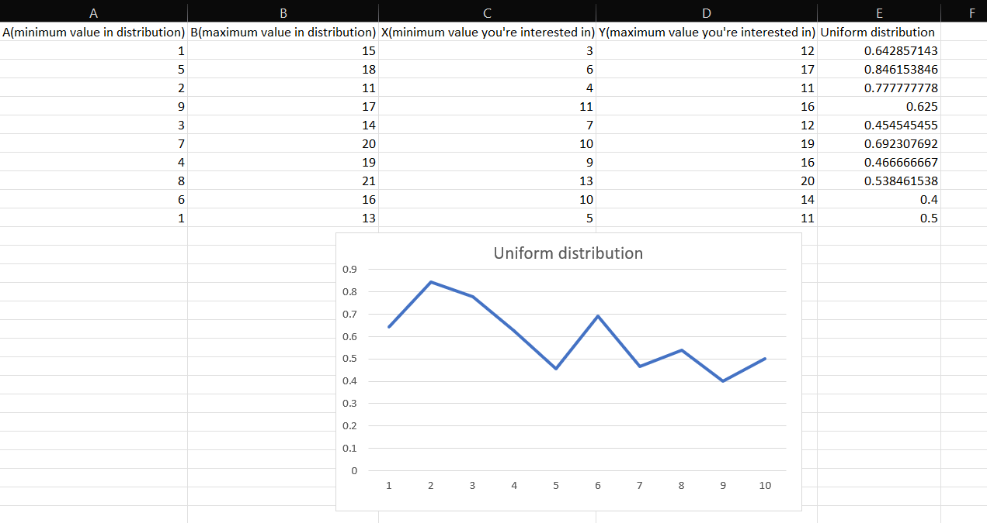

Formula=(D2-C2)/(B2-A2)

which gives uniform distribution

**6.Plotting and fitting of Exponential distribution and graphical representation of probabilities**

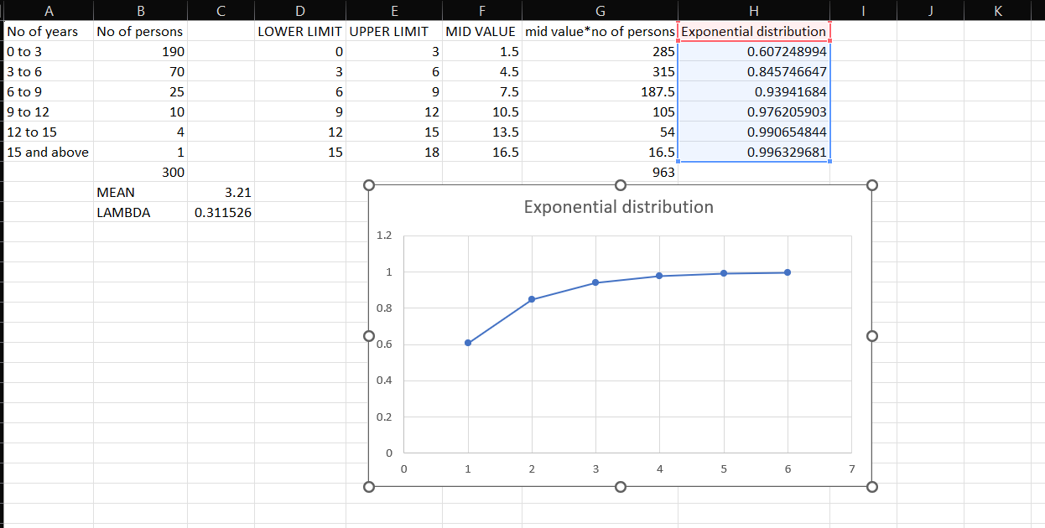

Formula:  
=SUM(G2:G7), =SUM(B2:B7)

MEAN=G8/B8

LAMBDA=1/C9

EXPONENTIAL DIST=EXPON.DIST(E2,C10,TRUE)